
10/11/2025
Project Image Processing
College of Information Technology
Medical Image Analysis for Cancer Cell Classification Using MATLAB
A MATLAB-Based Approach for Medical Image Enhancement and Cell Classification
Team number: G17
Members by University ID Number:
- 202402593
- 202300700
- 202402687
- 202402595

Digital Image Processing Project Documentation

Introduction
This document provides a detailed explanation of the Digital Image Processing project at Zarqa University. It includes objectives, tools used, implementation steps, and a presentation and analysis of the results.

Project Objectives
- Explain the mechanisms of applying digital transformations to images.
- Analyze the impact of each transformation on image quality and visual characteristics.
- Compare results before and after processing.

Project Steps
1. Import the original image.
2. Apply the required transformations.
3. Display the images before and after processing.
4. Analyze the results visually and theoretically.
5. Save the output images for inclusion in the final report.

Applied Transformations:

Negative Transformation
The negative transformation inverts the intensity of each pixel in the image so that dark areas become bright and bright areas become dark.
Mathematical Formula:
S = L - 1 – r
The transformation is defined mathematically as:
$$s=255-r$$
Effect on the image:
- Enhances details in dark regions.
- Improves edge visibility in images with unbalanced contrast.
- Useful when important image features are very dark compared to the background.

Results

Before and After Negative Transformation
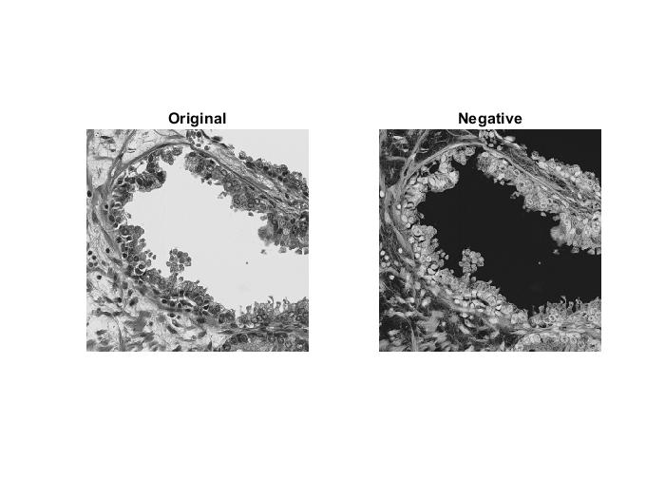

Results
After Applying the Negative Transformation
- The image becomes visually inverted:
  - The bright background turns dark.
  - The dark nuclei and tissue structures become bright.
- More internal details become visible inside regions that were originally very dark.
- Edges and boundaries between tissue structures become easier to distinguish.
- The transformation does not alter the actual image content; it only redistributes intensity values, which helps reveal hidden details.

Overall Effect
- Enhance fine structures within dark regions.
- Reduces the visual distraction caused by bright backgrounds.
- Improves the perceptual clarity of small features and subtle textures

Code Used for Negative Transformation
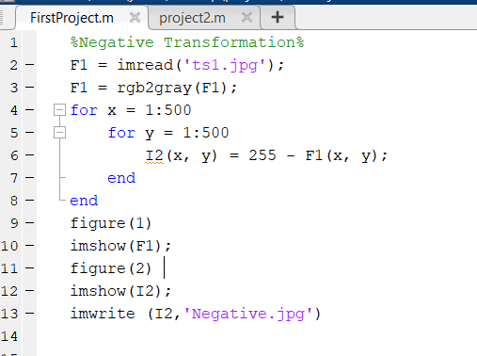

Conclusion
The negative transformation plays an important role in revealing hidden details within dark regions, making it one of the essential transformations in digital image processing.

Contrast Stretching

Introduction
Contrast Stretching is an intensity transformation technique used to enhance low-contrast images by expanding their dynamic range.
The purpose of contrast stretching is to redistribute pixel intensities so that they span the full range $[0,255]$, making image details clearer and more distinguishable.

Mathematical Formula
Let:
$$r_{min}=min⁡(r),r_{max}=max⁡(r)$$
Contrast stretching uses the following transformation:
$$s=\frac{r-r_{min}}{r_{max}-r_{min}}×(L-1)$$
For an 8-bit image $(L=256)$:
$$s=\frac{r-r_{min}}{r_{max}-r_{min}}×255$$
This function maps a narrow input range of intensities to the full output range, resulting in increased contrast.

Effect on the Image
- Enhances the separation between dark and bright areas.
- Reveals subtle details that were previously compressed in a narrow intensity window.
- Improves visibility of edges and fine structures.
- Useful for medical, microscopic, and scientific images requiring clearer visual interpretation.

Results

Before and After Contrast Stretching
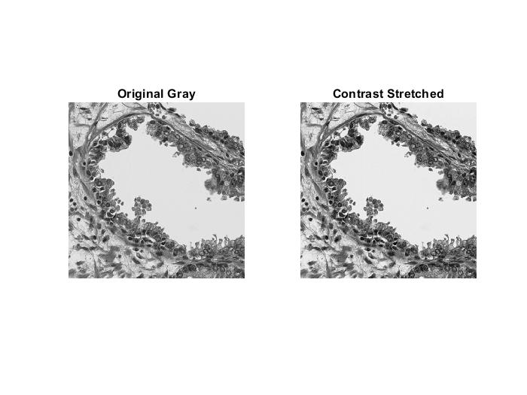
- The original grayscale image shows limited contrast, with most pixel values clustered in a narrow range.
- After contrast stretching, the intensity range expands to the full 0–255 scale.
- Details in the tissue, nuclei, and surrounding structures become sharper and more visible.

Analysis of the Results
- Dark regions now exhibit clearer textures and patterns.
- Bright regions become more defined after expanding the intensity range.
- Boundaries and edges between tissue layers appear more distinct.
- The transformation does not change the content—only redistributes intensities for improved visibility.

Overall Effect
- Enhances contrast in low-contrast images.
- Improves structural clarity and fine detail visibility.
- Makes subtle textures easier to identify.
- Provides a visually improved version of the original grayscale image.

Contrast Stretching Implementation Code
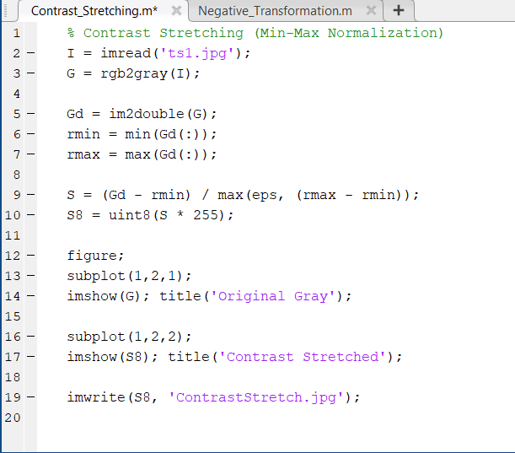

Conclusion
Contrast Stretching is an essential preprocessing technique in digital image processing.
By mapping a narrow intensity range to the full grayscale spectrum, it significantly enhances image clarity, highlights hidden structures, and improves the interpretability of scientific and medical images.

Thresholding (Binary Transformation)

Introduction
Thresholding is one of the simplest and most widely used intensity transformations in digital image processing. It converts a grayscale image into a binary image, where each pixel is classified as either black (0) or white (1 or 255) depending on whether its intensity is below or above a chosen threshold value T. This technique is useful for separating objects from the background and for highlighting specific structures in an image.

Mathematical Formula
The chapter defines thresholding as:
$$s=\{\begin{matrix}1, & r>T \\ 0, & r≤T\end{matrix}$$
And for an 8-bit image (to create a binary image of 0 and 255):
$$s=\{\begin{matrix}255, & r>T \\ 0, & r≤T\end{matrix}$$
This transformation turns all bright pixels into white and all dark pixels into black.
This is exactly what the chapter explains in the slide:
"Pixels above 150 become 1, pixels below 150 become 0."

Code Used for Thresholding Transformation
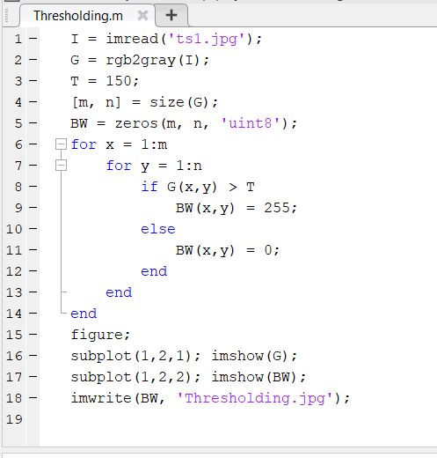

Results
Before and After Contrast Stretching
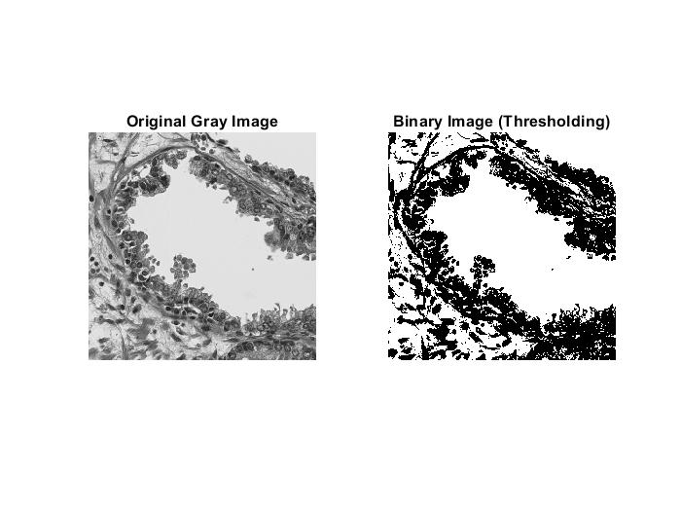
Before Thresholding (Gray Image)
- The grayscale image contains many intensity levels between 0 and 255.
- Some regions are bright, others dark, and some mid-level.
After Thresholding (Binary Image)
- All pixels brighter than the threshold become white (255).
- All pixels darker than the threshold become black (0).
- Structures like nuclei, tissue regions, and boundaries become more sharply separated.

Analysis of the Results
- The binary image clearly separates bright regions from dark regions.
- Complex textures in the grayscale image are converted into simple black–white regions for easier analysis.
- Thresholding removes intensity variations and keeps only essential structural information.
- Useful for segmentation, object counting, and shape extraction.

Overall Effect
- Simplifies the image by reducing 256 possible values into only two.
- Enhances object/background separation.
- Makes important structures easier to detect.

Conclusion
Thresholding is a fundamental intensity transformation that converts a grayscale image into a binary image based on a specified threshold value. It is particularly effective for separating objects from their background and is widely used in image segmentation, medical imaging, and pattern recognition.

Log Transformation

Introduction
The Log Transformation is a nonlinear intensity transformation used to enhance the visibility of details in dark regions of an image. logarithmic functions are part of the Basic Intensity Transformations and are particularly useful when pixel values are heavily concentrated in the darker portion of the histogram.
This transformation expands low-intensity values and compresses high-intensity values, making it highly effective for images that contain dark areas with hidden or low-contrast details.

Mathematical Formula:
The general log transformation is defined as:
$$s=c⋅log⁡(1+r)$$
Where:
- $r$= input pixel intensity
- $s$= output pixel intensity
- $c$= scaling constant
- log is applied to normalize the output
In an 8-bit system (0–255), we use normalized intensities:
$$r=\frac{\text{pixel}}{255}$$
And then later scale back to 0–255.

Code Used for Thresholding Transformation
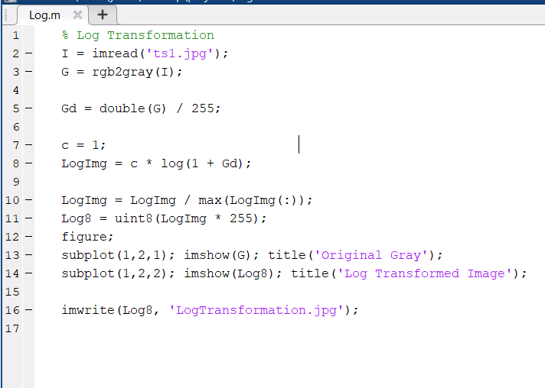

Results
Before and After Log Transformation
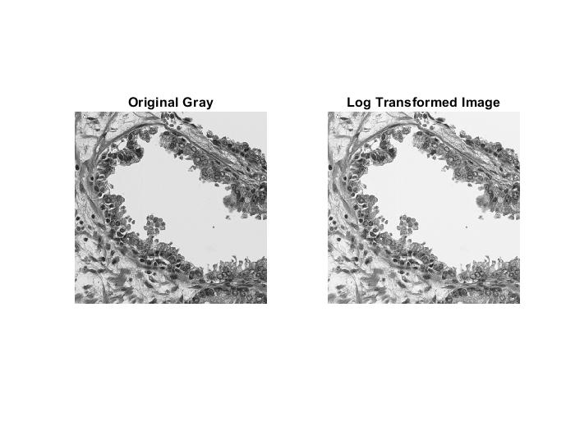
Before Log Transformation
- The grayscale image contains many dark regions with fewer details visible.
- Intensities are compressed in the lower range of the histogram.
After Log Transformation
- Low-intensity (dark) regions become brighter.
- Hidden textures and details become more visible.
- High-intensity regions are compressed, preventing over-brightening.
- Overall image becomes more balanced for human interpretation.

Analysis of the Results
- The log function expands low values and compresses high values.
- This causes subtle patterns in dark regions to appear with clearer contrast.
- It is highly effective for microscopy, night images, and X-ray enhancement.
- The transformation does not create new details; it reveals existing but hidden information.

Overall Effect
- Enhances dark regions significantly.
- Balances the brightness of the image.
- Reduces the dominance of bright areas.
- Improves overall visual clarity.

Conclusion
Log Transformation is an essential nonlinear intensity transformation that enhances visibility in dark regions by expanding the lower end of the intensity scale. It is particularly useful for scientific, astronomical, and medical images where important details may be hidden within low-light areas.

Gamma Transformation (Power-Law Transformation)

Introduction
Gamma Transformation, also known as Power-Law Transformation, is a nonlinear intensity transformation used to control the brightness and contrast of an image. Gamma transformations are widely applied in display systems, image enhancement, and camera correction to adjust image appearance and improve visual clarity.

The effect depends on the value of gamma (γ):
- γ < 1 → brightens the image
- γ > 1 → darkens the image
- γ = 1 → no change
This makes gamma correction a flexible method for enhancing specific intensity ranges.

Mathematical Formula:
The transformation is defined as:
$$s=c⋅r^{γ}$$
Where:
- $r$= input normalized pixel intensity
- $s$= output intensity
- $c$= scaling constant (typically 1)
- $γ$= Gamma value controlling brightness
In practice, intensities must be normalized to $[0,1]$before applying the power-law function, then scaled back to $[0,255]$.

Code Used for Gamma Transformation (Power-Law Transformation)

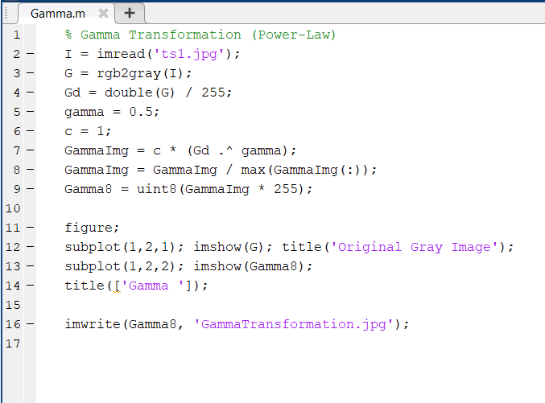

Results
Before and After Gamma Transformation
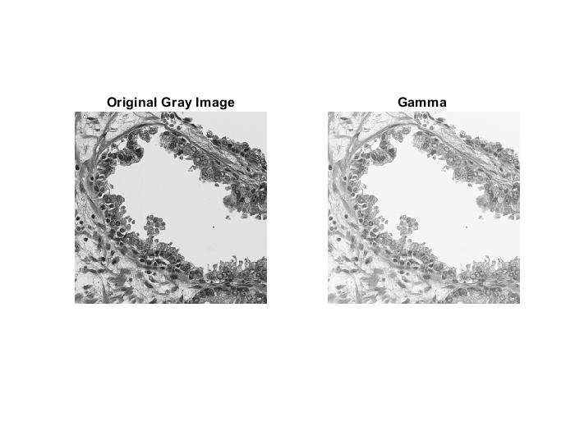
Before Gamma Correction
- The grayscale image has limited brightness in darker areas.
- Some textures appear dim and less visible.
After Gamma Correction ($γ=0.5$)
- The image becomes brighter overall.
- Dark regions gain more detail and appear clearer.
- High-intensity regions are only slightly affected.
- Midtones are enhanced, improving visual clarity.

Analysis of the Results
- The power-law function increases pixel values when γ < 1, making it ideal for enhancing dark images.
- Gamma correction is widely used in image display devices to match human visual perception.
- Dark to mid-range intensities receive the greatest enhancement.
- The transformation preserves the structure of the image while adjusting brightness distribution.

Overall Effect
- Brightens the image when γ < 1.
- Enhances visibility of structures in dark areas.
- Provides smooth and natural brightness adjustment.
- Useful for medical, microscopy, and low-light photography.

Conclusion
Gamma Transformation is a powerful nonlinear method that adjusts image brightness according to a power-law curve. By selecting an appropriate gamma value, it is possible to enhance dark regions or reduce excessive brightness, making gamma correction an essential technique in many imaging applications.

Piecewise Linear Transformation

Introduction
Piecewise Linear Transformation is a flexible intensity transformation technique in which the output image is produced using a function composed of multiple linear segments. Piecewise functions are particularly useful for enhancing specific ranges of intensity values rather than modifying the entire image uniformly.
This technique can:
- enhance dark regions,
- suppress bright regions,
- emphasize a specific intensity range,
- or improve overall image contrast in a controlled way.

Concept
A piecewise linear function is defined by dividing the intensity range into sections, and each section has its own linear equation.
The general form is:
$$s=\{\begin{matrix}a_{1}r+b_{1}, & 0≤r<r_{1} \\ a_{2}r+b_{2}, & r_{1}≤r<r_{2} \\ a_{3}r+b_{3}, & r_{2}≤r≤1\end{matrix}$$
Where:
- $a_{1},a_{2},a_{3}$are slopes
- $b_{1},b_{2},b_{3}$are intercepts
- $r_{1},r_{2}$are breakpoints

The custom Function
$$s=\{\begin{matrix}1.8r, & 0≤r<0.25 \\ (r-0.25)+0.45, & 0.25≤r<0.75 \\ 0.95+0.5(r-0.75), & 0.75≤r≤1\end{matrix}$$
This function is continuous, smooth, and enhances the important dark structures in your microscope-like image.

Code Used for Piecewise Linear Transformation
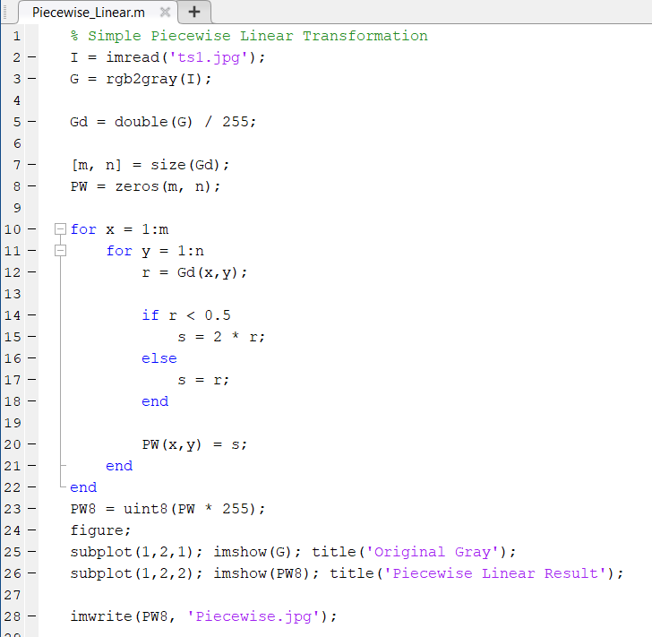

Analysis of the Results

- The high slope in dark regions enhances visibility significantly.
- The mid-slope (1.0) keeps natural tissue texture intact.
- The low slope in bright areas compresses highlight intensity.
- This function gives custom control not achievable with any single log or gamma function

Results
Before and After Piecewise Linear Transformation
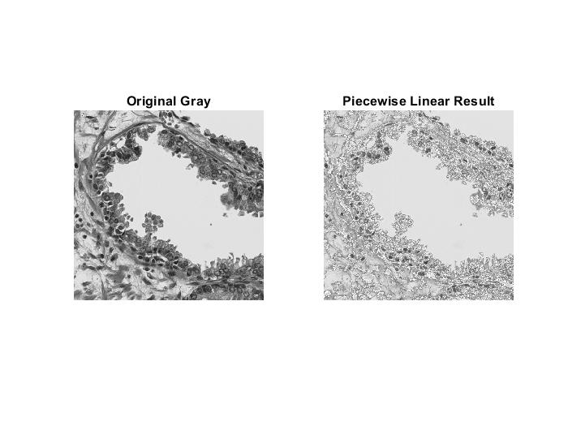
Before Piecewise Transformation
- Dark regions hide details.
- Bright regions are too dominant.
- Midtones are visible but not well emphasized.
After Piecewise Transformation
- Dark structures (nuclei, details) become brighter and more visible.
- Midtones remain naturally balanced.
- Bright areas are slightly suppressed to prevent saturation.
- Overall contrast becomes more controlled and visually pleasing.

